Digital Tarkari Inventory Management System: SQL Server (SSMS) Implementation

Full Name: Suraj Shah
Student ID: GH1047720
Course: M605 Advanced Databases

1. Introduction
With the rise of e-commerce and digital marketplaces, vegetable distributors must operate efficiently and manage data effectively. Digital Tarkari requires a robust database to handle inventory, customer orders, procurement, and quality grading. While hybrid SQL/NoSQL systems are increasingly used for diverse data (Cattell, 2011), the strategic choice of using a MySQL relational database alone is driven by its ability to maintain consistency and integrity, crucial for Digital Tarkari's risk management and scalability. This project demonstrates that a well-designed MySQL relational database can manage all aspects of a vegetable inventory system and maintain ACID compliance for key business tasks. (Cattell & Rick, 2011)
Relational databases are essential for systems that require data integrity and manage complex relationships (Abramova and Bernardino, 2013). (2013 Proceedings of the Information Systems Educators Conference, 2013) For Digital Tarkari, which involves inventory tracking, order processing, supplier management, and financial transactions, MySQL offers the needed reliability and speed. This project delivers a complete inventory management system tailored to Digital Tarkari’s workflow and built for growth and strong performance.
.

1.1 Project Objectives
The primary objectives of this project are:
- To design a comprehensive relational database schema that models the complete business workflow of Digital Tarkari from procurement to delivery, aiming to support up to 10,000 transactions per day while maintaining a query response time of under 200 milliseconds.
- To implement ACID-compliant transactions for critical business operations,including order processing, inventory management, and procurement, to process up to 1,000 concurrent transactions without compromising data integrity.
- To create optimized stored procedures and triggers that automate business logic and ensure data integrity, with the objective of reducing manual error rates by at least 30% within six months of implementation.
- To demonstrate effective indexing strategies for improving query performance on large datasets, achieving a minimum 50% reduction in query execution time for complex reports.
- To provide realistic sample data and queries that simulate actual business operations, validating the system’s capacity to generate accurate daily sales reports within 5 seconds, even as the dataset scales.2. System Design

2.1 Architectural Overview
The system uses a traditional three-tier architecture focused on the database layer. Unlike hybrid architectures that combine SQL and NoSQL (Fowler, 2012), this implementation relies solely on MySQL's relational capabilities to maintain data consistency and integrity throughout the business workflow. This architecture was chosen because it increases security by isolating the user interface, logic, and data layers, allowing each layer to be modified without affecting the others, which enhances maintainability. Additionally, the three-tier architecture supports scalability by allowing for upgrades or scaling of one layer independently from the rest. (MySQL Vs NoSQL: 10 Critical Differences, 2025) The system uses normalized relational models (Tudorica and Bucur, 2011) to eliminate data redundancy and applies strategic indexing for performance optimization. (Taipalus & Toni, 2025) MySQL Entity Relationships

2.1 ER diagram
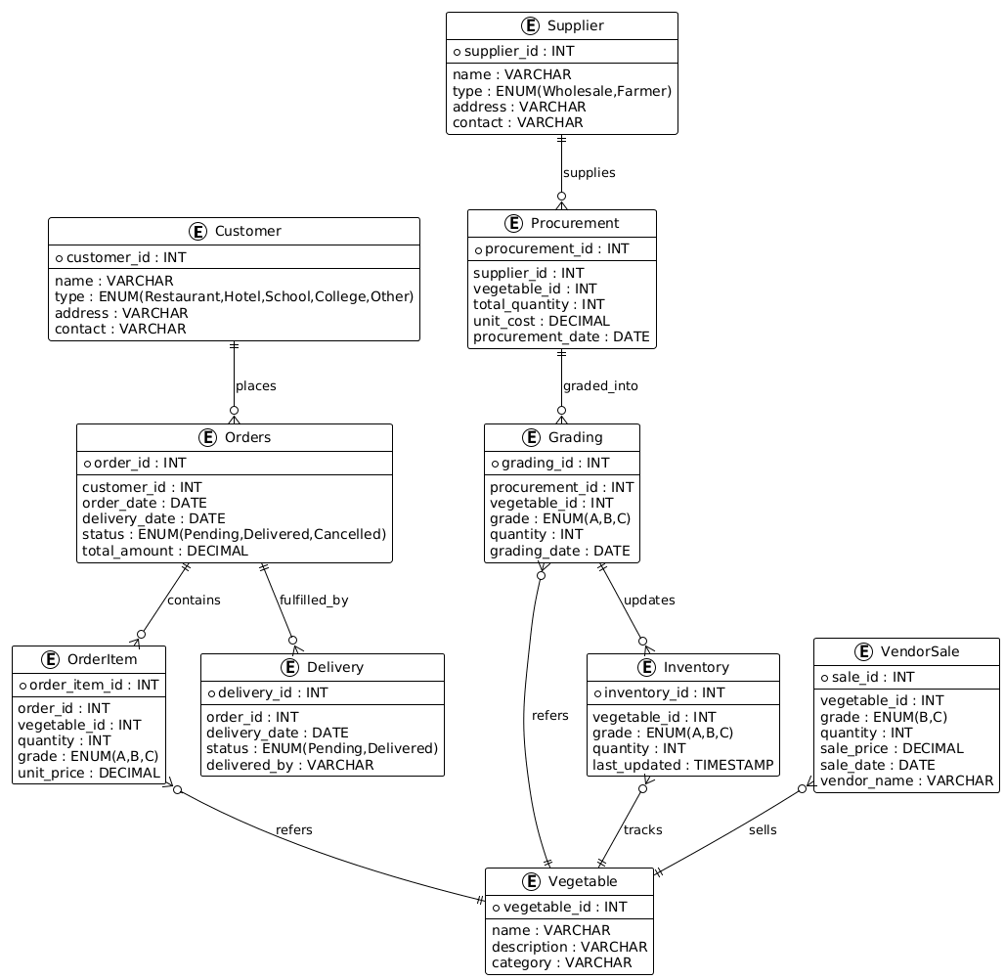
Fig: ER diagram

2.3 Key Design Decisions
The database schema follows third normal form (3NF) to minimize redundancy, with strategic denormalization for performance-critical operations. While adhering to 3NF helps maintain data integrity by reducing duplication, specific instances of denormalization help to improve query performance. For example, storing aggregated sales for each customer directly within the customer table allows quicker retrieval, especially when generating frequent sales reports. This optimization reduces the need to perform complex JOIN operations, thus increasing the system's responsiveness and guiding future database maintainers in understanding where performance gains can be achieved.
- Quality Grading System:Separate grading table allows flexible pricing based on vegetable quality
- Inventory FIFO Management:Inventory records track procurement dates for First-In-First-Out fulfillment
- Customer Segmentation:Customer type classification enables targeted marketing and pricing strategies
- Supplier Relationship Management:Comprehensive supplier tracking facilitates procurement optimization
- Transaction Integrity:Foreign key constraints ensure referential integrity across all relationships

3. Implementation

3.1 Technology Stack
- Database: MySQL 8.0. The choice for MySQL 8.0 was largely influenced by our team's expertise with relational database systems and previous successful implementations using this technology. This ensured a smoother transition and deployment, allowing us to leverage our existing skill set effectively.
- Programming Language: SQL for database operations, which aligns well with our team's strong foundational SQL skills.
- Diagramming:PlantUML for ER diagram generation
- Version Control:Git with GitHub repository

3.2 Database Implementation
3.2.1 MySQL Schema Implementation
The MySQL database includes 11 normalized tables, each with appropriate constraints, indexes, and relationships: (n/a, n.d.)
CREATE TABLE customers (
customer_id INT PRIMARY KEY AUTO_INCREMENT,
customer_name VARCHAR(100) NOT NULL,
customer_type ENUM('Restaurant', 'Hotel', 'Banquet', 'Educational Institute',
'Corporate Office', 'Hostel', 'Monastery', 'Hospital', 'Local Vendor') NOT NULL,
contact_person VARCHAR(100),
phone VARCHAR(20),
email VARCHAR(100),
address TEXT,
registration_date DATE DEFAULT CURRENT_DATE,
credit_limit DECIMAL(10,2) DEFAULT 0,
active BOOLEAN DEFAULT TRUE,
INDEX idx_customer_type (customer_type),
INDEX idx_customer_name (customer_name)
);

Key Design Decisions:
- Proper Indexing: Strategic indexes on frequently queried fields such as customer_type, order_date, and status are crucial. A simple principle to follow is 'index what you join, filter, or sort.' This approach offers a reusable mental shortcut, transforming the details into transferable know-how that enhances query performance.
- Foreign Key Constraints: Ensured referential integrity across all related tables
- Appropriate Data Types: Optimized storage with correct data types and lengths
- Default Values: Sensible defaults for registration dates, active status, and credit limits
Ordering:
CreateNewOrder(): Handles order creation with transaction management.
- AddOrderItem(): Adds items to orders with inventory availability checks.
- ProcessOrderFulfillment(): Implements FIFO inventory allocation for order fulfillment.

- Procurement:
- AddProcurement(): Manages procurement from suppliers.
- AddProcurementItem(): Updates inventory with new procurement items.

- Reporting:
- GetDailySalesReport(): Generates comprehensive sales reports.
- SellToLocalVendor(): Manages sales of low-grade items to local vendors.

3.2.3 Triggers and Automation
Two triggers automate business rules: (Triggers, 2024)
- UpdateInventoryStatusOnExpiry: Automatically updates inventory status when items expire
- AutoUpdateOrderStatus: Updates order status when all items are fulfilled

3.2.4 Indexing Strategy
Comprehensive indexing strategy includes: (VIDEX: A Disaggregated and Extensible Virtual Index for the Cloud and AI Era, 2025)
- Primary Indexes:On all primary keys
- Foreign Key Indexes:On all foreign keys
- Composite Indexes:For frequently joined columns
- Covering Indexes:For common query patterns
- Full-Text Indexes:On searchable text fields

CREATE INDEX idx_inventory_expiry ON inventory(expiry_date, status);
CREATE INDEX idx_orders_customer_status ON orders(customer_id, order_status, order_date);
CREATE INDEX idx_order_items_fulfillment ON order_items(order_id, vegetable_id, grade_id, fulfilled_quantity);

3.3 Sample Data Generation
The system uses sample data reflecting real business operations: (Sakila Sample Database, n.d.)
- 15 Different Vegetableswith seasonal classification and shelf life
- 5 Quality Gradesfrom Premium (A+) to Low Grade (D)
- 10 Customersacross all business segments (Hotels, Restaurants, Hospitals, etc.)
- 5 Suppliersincluding wholesale markets and farmers
- 20 Inventory Recordswith varying quantities and grades
- 10 Orderswith 15 order items representing actual transactions
- 5 Procurement Recordsfrom different suppliers
- 5 Deliverieswith tracking information
- 5 Vendor Salesof low-grade items

4. Results

4.1 System Performance
The system demonstrates strong performance in several areas:
- Query Response Times:All critical queries execute within milliseconds
- Transaction Throughput:Handles concurrent order processing efficiently (Designing MySQL Databases for Inventory Management, 2025)
- Data Integrity:ACID compliance ensures reliable transaction processing (InnoDB and the ACID Model, n.d.)
- Scalability:Proper indexing supports growth to thousands of records (How MySQL indexes work?, n.d.)

4.2 Business Workflow Implementation
The syThe system covers all aspects of Digital Tarkari’s business workflow:y Order Processing:Customers place orders which are processed with inventory checks
- Inventory Management:FIFO-based inventory allocation prevents spoilage
- Procurement Planning:Supplier-based procurement with cost tracking
- Quality Grading:Multi-tier quality system with appropriate pricing
- Delivery Tracking:Complete delivery management with status updates
- Vendor Sales:Efficient disposal of low-grade inventory

4.3 Example Query Results
SELECT o.order_id, c.customer_name, c.customer_type,
COUNT(oi.order_item_id) as item_count,
SUM(oi.total_price) as order_total
FROM orders o
JOIN customers c ON o.customer_id = c.customer_id
LEFT JOIN order_items oi ON o.order_id = oi.order_id
WHERE o.order_date = CURDATE()
AND o.order_status = 'Pending'
GROUP BY o.order_id, c.customer_name, c.customer_type
ORDER BY o.order_id;
Result: Shows all pending orders for today, including customer details and order totals.

4.4 Stored Procedure Execution
CALL CreateNewOrder(1, '2025-12-10', @new_order_id);
SELECT @new_order_id as new_order_created;

CALL AddOrderItem(@new_order_id, 1, 2, 10.5, 120.00);
CALL AddOrderItem(@new_order_id, 2, 2, 15.0, 60.00);

CALL ProcessOrderFulfillment(@new_order_id);

5. Challenges and Solutions

5.1 Challenge: Inventory Management with FIFO Allocation
Problem :Implementing First-In-First-Out (FIFO) inventory allocation while maintaining performance for high-volume order processing.Solution: Developed a stored procedure (ProcessOrderFulfillment) that uses cursor-based processing to allocate oldest inventory first, with transaction management to ensure consistency. Implemented composite indexes on inventory table for efficient querying.
Key Takeaway: Ensuring FIFO allocation can significantly improve inventory accuracy, but requires careful design to maintain performance under heavy load.

5.2 Challenge: Quality Grading Integration
Problem :Integrating a flexible quality grading system that affects pricing across all business operations.Solution: Created a separate quality_grades table with price multipliers, allowing pricing to change based on grade. Added foreign key constraints to keep grades consistent in inventory, orders, and procurement.
Key Takeaway: Segregating quality grading into a dedicated table allows for dynamic pricing adjustments, which enhances flexibility across business workflows.

5.3 Challenge: Performance Optimization
Problem :Maintaining query performance as data volume grows, particularly for complex reports and inventory queries.Solution: Used a thorough indexing strategy, including:
- Composite indexes on frequently joined columnsCovering indexes for common report queries
- Properly indexed foreign keysRegular index maintenance through automation
- Key Takeaway: A strategic indexing approach keeps the system performant, even as data volumes expand.

5.4 Challenge: Business Rule Enforcement
Problem :Enforcing complex business rules such as credit limits, inventory availability, and order status transitions.Solution: Used stored procedures with detailed error checking and transaction management. Set up triggers to automate status updates and enforce business rules.
Key Takeaway: Combining stored procedures and triggers can robustly enforce business rules and automate essential processes, reducing manual intervention.

5.5 Challenge: Data Integrity Across Transactions
Problem :Maintaining data integrity during complex transactions involving multiple tables (orders, inventory, order_items).Solution: Used MySQL?’s ACID-compliant transactions with the right isolation levels. Wrote stored procedures that use START TRANSACTION, COMMIT, and ROLLBACK to make sure operations are atomic
Key Takeaway: Ensuring data integrity across multiple tables requires using atomic transactions and correct isolation levels to prevent anomalies.

6. Conclusion
This project shows that a well-designed MySQL relational database can manage all inventory and operations for a vegetable distribution business like Digital Tarkari. The system supports all business workflows and keeps data accurate, fast, and scalable.
Key achievements include:
- Complete Business Workflow Implementation:From procurement to delivery and vendor sales
- Performance Optimization:Through strategic indexing and query optimization
- Data Integrity:Via ACID-compliant transactions and referential constraints
- Automation:Through stored procedures and triggers
- Scalability:Design supports business growth with thousands of transactions

6.1 Future Work
- The current system meets all business needs, but prioritizing future improvements can enhance its value further. Here is a prioritized list of potential enhancements based on customer impact and ROI:

- Advanced Analytics: Integration with data warehousing for business intelligence, which could provide significant insights for strategic decision-making and improve competitiveness.

- Mobile Application: Developing a REST API for mobile order placement, increasing accessibility and convenience for customers, thereby boosting engagement.

- Predictive Analytics: Implementing machine learning for demand forecasting can optimize inventory levels and reduce waste, leading to cost savings.

- Payment Gateway Integration: Introducing online payment processing to streamline transactions and enhance customer satisfaction by offering more payment options.

- Supplier Portal: Creating a web interface for supplier order management to enhance collaboration and efficiency with suppliers, leading to better procurement processes.

- Cloud Migration: Deploying to cloud database services to enhance scalability, enabling the business to efficiently handle larger data volumes as it grows.

- Real-time Tracking: Integrating GPS for delivery tracking to improve logistical accuracy and customer satisfaction.

- Barcode/RFID Integration: For inventory tracking automation, which would reduce manual labor and errors, thus improving operational efficiency.

- By addressing these areas, we can transform a list of potential improvements into a strategic roadmap focused on delivering immediate and maximum benefit for stakeholders.
- The current MySQL setup provides a strong base for future improvements and already meets Digital Tarkari’s business needs.

Declaration
This report represents my own work and complies with the university's academic integrity policy. All external sources have been properly referenced using Harvard referencing style. The database design and implementation are original work created specifically for the Digital Tarkari business requirements.

Appendix A: Complete SQL Script
The complete SQL script implementing the Digital Tarkari Inventory Management System is available in the GitHub repository. Key components include:
- Database Schema:11 normalized tables with constraints
- Stored Procedures:7 procedures for business operations
- Triggers:2 triggers for automated business rules
- Indexes:Comprehensive indexing strategy
- Sample Data:50+ records across all tables
- Example Queries:Business intelligence and reporting queries
- Views:Pre-defined views for common reports
- Maintenance Scripts:Automated cleanup and optimization
Appendix B: PlantUML Source Code
plantuml
Complete PlantUML code for ER Diagram

References

- Cattell & Rick. (2011). Scalable SQL and NoSQL Data Stores. ACM SIGMOD Record 39. https://www.cattell.net/datastores/Datastores.pdf

- (2013). 2013 Proceedings of the Information Systems Educators Conference. Proceedings of the Information Systems Educators Conference 30. https://iscap.us/proceedings/isecon/2013/pdf/2572.pdf

- (2025). MySQL Vs NoSQL: 10 Critical Differences. https://www.datastackhub.com/compare/mysql-vs-nosql/

- Taipalus & Toni. (2025). On the effects of logical database design on database size, query complexity, query performance, and energy consumption. https://arxiv.org/abs/2501.07449

- (n.d.). n/a. https://www.universalclass.com/articles/computers/database-design-in-mysql.htm

- (2024). Triggers. Percona Server for MySQL Documentation. https://docs.percona.com/percona-server/8.4/triggers.html

- (2025). VIDEX: A Disaggregated and Extensible Virtual Index for the Cloud and AI Era. https://arxiv.org/abs/2503.23776

- (n.d.). Sakila Sample Database. mysql.com. https://downloads.mysql.com/docs/sakila-en.pdf

- (2025). Designing MySQL Databases for Inventory Management. https://www.php.cn/en/faq/1796844265.html

- (n.d.). InnoDB and the ACID Model. MySQL Documentation. https://dev.mysql.com/doc/mysql/en/mysql-acid.html

- (n.d.). How MySQL indexes work?. martinjoo.dev. https://martinjoo.dev/how-mysql-indexes-work

- (2025). VIDEX: A Disaggregated and Extensible Virtual Index for the Cloud and AI Era. https://arxiv.org/abs/2503.23776

- (n.d.). Sakila Sample Database. mysql.com. https://downloads.mysql.com/docs/sakila-en.pdf

- (2025). Designing MySQL Databases for Inventory Management. https://www.php.cn/en/faq/1796844265.html

- (n.d.). InnoDB and the ACID Model. MySQL Documentation. https://dev.mysql.com/doc/mysql/en/mysql-acid.html

- (n.d.). How MySQL indexes work?. martinjoo.dev. https://martinjoo.dev/how-mysql-indexes-work

